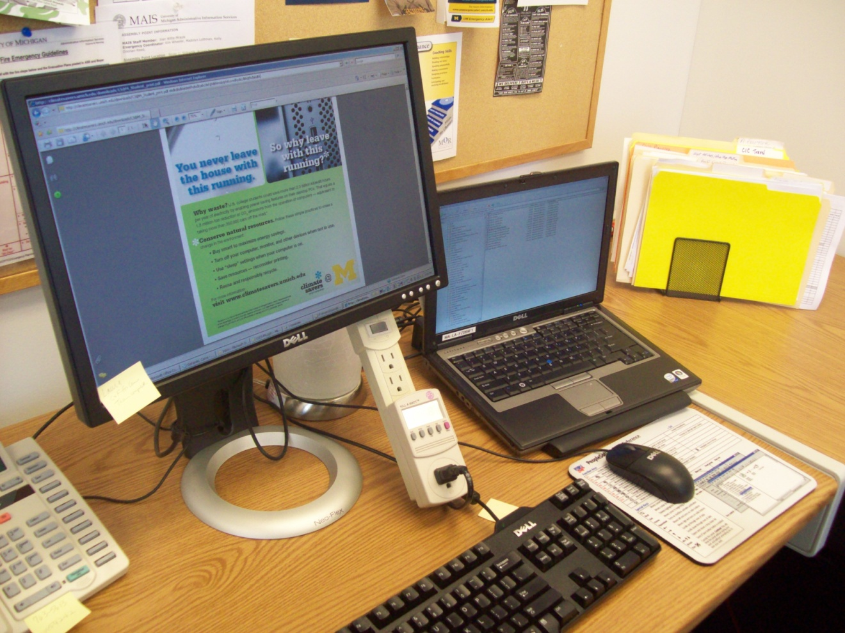

Table of Contents
Table of Contents 2
objective 3
Document Summary 3
About our existing workstation environment 3
The numbers 3
Configuration & Maintenance Norms 4
Assignment & Purchasing Norms 4
Networking and Remote Access Norms 4
Past and Future Efforts to Improve Efficiency 5
Monitors 5
Power-off and Dealing with Software Updates 5
Printing 5
Virtualization 5
ADDRESSING The desktop best practices for IT professionals 6
Getting Buy-in 6
Communicating with Our Users 6
Measuring Where We Were Starting From 6
Promote Energy-Saving Behavior 7
Buy Smart 7
Provide ‘Smart’ Power Strips 7
Configure Default Energy-Savers 8
Re-evaluate the Printing Environment 8
Reuse and Responsibly Recycle Computer Equipment 8
Power management policY SETTINGS 10
BIOS Configuration Updates 10
AC power Recovery Mode: Last 11
Auto Power On: Weekdays set for 5:00am 11
Low Power Mode: S3 11
WakeUp On Lan: Enabled 11
Configuration Password 11
Operating System Settings 11
Enable “Allow this device to bring the computer out of standby”. 11
Enable S3 system power state for standby when USB devices are armed for wake. 11
Registry paths need read/write access for non-admin XP users to set power schemes. 11
Creating the Policies 12
Testing the Policies 12
Issues Identified 12
Deployment of the Settings 13
Results 13
Next steps 13
Additional Techniques & references 14
Shutdown Task 14
Standby/Sleep Task 14
References to Supporting Documentation 15

objective
The University of Michigan Administrative Information Services department (MAIS) is committed to playing a leading role for the campus Climate Savers Computing Initiative (CSCI). We are determined to help the University community by testing, implementing and promoting the energy efficient and sustainable computing practices covered in the CSCI best practices.
Our green system configurations and procedures are tested and manageable with respect to our department’s existing business practices, remote access practices, and system maintenance practices.
In most cases, we believe energy efficient system configurations and best practices should take precedence over individual preferences. Exceptions to the policies are carefully reviewed and documented.
This document may best serve as a single case study or documentation template for IT professionals implementing the CSCI workstation best practices within a University department. We encourage IT professionals to document and share their experiences and solutions.

Document Summary
This document briefly describes:
- The MAIS workstation environment
- Previous efforts to conserve energy and improve efficiency
- How Business and Finance IT (BFIT) has addressed the CSCI workstation best practices for MAIS
The document will also cover our power management settings and techniques we used to improve efficient by default workstation and printing configurations. Some exception accommodations and on-going challenges will also be covered.

About our existing workstation environment
We are standardized on Dell Windows systems in the organization, though we have a few (about 7) Macs.

The numbers
Employees | 400+
Total Workstations | 500+  including 85 shared systems in training rooms, conference rooms, a loaner laptop pool, etc.
Laptops | 165
Desktops | 326
Network Copiers | 12
Network Printers | 21
Desktop Printers | 62

Configuration & Maintenance Norms
Systems run Windows XPSP3, built by a scripted process and a custom group policy-based patch process. We are currently testing Windows Vista.
Our normal workstation maintenance window is Thursday night. We send workstation maintenance notifications on Tuesdays and Thursdays, and those notices instruct our staff to shut down their computers when they leave work.
We use Active Directory, Automatic Updates, and SCCM to manage software and system updates.

Assignment & Purchasing Norms
Staff are provided with a single workstation each. All of our workstations are using LCD displays; about half of our systems use dual monitor configurations for increased productivity. Secondary desktop computers are seldom provided.
Although CSCI best practices recommend using laptops, at MAIS we ask for supervisor approval & awareness on all new laptop purchases to help control our costs; new laptops are still almost twice the cost of new desktops.
All workstation hardware and software purchasing is managed by BFIT. Most of our existing desktops are Ultra-Small Form Factor Optiplex GX620, 745, and 755 models; most laptops are D620 and D630 Latitude models. Our average workstation has 1 or 2 GB of RAM with a dual-core CPU.
New purchases are Energy Star 4.0 & EPEAT Gold rated Dell Optiplex 755 SFF (quad-core) and Latitude E6400 (dual-core) models, all with 4GB of RAM.

Networking and Remote Access Norms
The majority of our workstations are connected to 100mbit switched network ports.
MAIS does not support using remote desktop services on workstations. Instead, we provide shared remote desktop terminal servers with applications, and we provide staff laptops and pool laptops that use VPN connections as necessary. We also have Outlook Web Access for basic remote email needs.

Past and Future Efforts to Improve Efficiency

Monitors
We started deploying LCD monitors in place of CRT’s in 2003, and finished in 2006. To date, the switch to LCD monitors provided the biggest energy improvement for desktops.

Power-off and Dealing with Software Updates
Around 2005 we discontinued the common practice of asking staff to leave their computers turned on 24/7. Instead, we started asking staff to power off when they leave work to save energy, and we updated our system maintenance procedures to accommodate that change.
To facilitate system updates and scheduled SMS software updates, BIOS settings were set to automatically power-on systems at 5 am on weekdays, ensuring that updates were installed before users arrived to work.
Note: Auto-on BIOS settings, without remote shutdown and other power management settings in place, may waste energy because systems may not be consistently put in standby or powered down when idle.

Printing
A few years ago, we made an effort to reduce the number of shared network printers. As part of our process, we standardized on Energy Star color-capable laser printers, setting them to print two-sided by default. To moderate toner usage, we set the printers to print in black-and-white by default, training users to override when needed. We also configured all our copiers to support network printing from our workstations.
Our staff typically only replaces toner cartridges when they are completely used up, not when they are low. We also make sure all spent toner cartridges are sent back for recycling or re-use.

Virtualization
MAIS started using virtualization for some of their enterprise servers around 2005. Since 2007 the desktop team has used departmental-level server virtualization to host a few test remote desktop workstations; we are also testing virtual applications for desktops.
MAIS is currently working on a Virtual Desktop Infrastructure (VDI) thin client proof of concept. The testing will include areas from within Business and Finance, Engineering, and the Institute for Social Research. The potential benefits include reduced energy usage at the workstation level, secure remote access to desktops, and reduced administration for managing virtual desktops.

ADDRESSING The desktop best practices for IT professionals
During the spring and summer of 2008, we worked with the Climate Savers Computing Initiative desktop technologies team to help develop the workstation best practices. Once the best practices were completed, we realized we had a lot of changes to work on and even identified a number of opportunities for additional improvements.

Getting Buy-in
Before we started making changes, we discussed each of the best practices internally to determine goals and strategies. We also kept our supervisors informed as we worked on the details, and we attended related meetings with other IT administrators and IT leaders from around the University.

Communicating with Our Users
We sent several email communications to our staff about our intentions to deploy the Climate Savers best practices to the majority of the MAIS workstations. We sent status updates as progress was being made and prior to making changes. We also provided to staff a few kilowatt meters that monitored energy consumption of desktops to encourage participation and support – and we allowed staff to take those meters home overnight to try them out.
We involved our normal test group staff to help us verify that our power management settings and policies didn’t cause problems. We also let all our users know they need to power-on or wake-up their own computers going forward, that we have procedures ready to manage temporary changes, and lastly that formal exceptions to the policies can be requested by submitting a help ticket.

Measuring Where We Were Starting From
We started measuring our systems with kilowatt meters when the Climate Savers project launched. There can be many factors involved when determining the actual energy usage for each workstation - conservative estimates based on samples and usage averages are often as good as it gets.
In September 2008 we co-sponsored a proof of concept for power and patch management software with MAIS, the School of Natural Resources and Environment (SNRE) and Engineering (CAEN). We deployed software agents to monitor usage for all our workstations and report on the activity. After a couple months we found that about 50% of the workstations being monitored were frequently left powered-on 24/7. Later on, kilowatt averages were added to the management tool for each model computer we had to help make our savings estimates more accurate.
We’ve also learned that off-the-shelf power management software can be used to measure, control, and report on the actual usage and savings for the University.
Our measuring efforts showed that we had the potential to save at least $25 a year on average per computer once power management policies were deployed and working as intended. That figure was based on the University’s cost per kilowatt at the time; the savings will naturally be more as energy costs continue to rise. We did not document the carbon emission savings estimates, as those are often difficult to calculate accurately.

Promote Energy-Saving Behavior
To help promote energy saving behavior to our user community, several MAIS staff and CSCI volunteers have sent email communications about Climate Savers and Planet Blue related activities. Numerous posters with Climate Savers best practice information have been displayed all around our buildings as well. We continually promote CSCI activities through the University Record, Michigan Daily and other media on and off-campus to keep eco-friendly computing top of mind.
We continue to remind our users to power-off their computer equipment when they leave, and we now include information on the CSCI best practices with our new user orientation procedures.

Buy Smart
For our workstations and printers, we only buy Energy Star products. Recently, new desktops and laptops purchased have also been Energy Star 4.0 and EPEAT gold certified.
We do not purchase the high-end CPU or memory options when configuring a system; the CPU model is typically mid-range with respect to per system cost savings, performance needs, and application system requirements.
We have increased the number of laptops in MAIS over the last two years, mostly because of the added mobility and industry trends. When configured as desktop replacement workstations, our laptops cost almost twice as much as our desktop workstations, so energy savings do not yet support purchasing laptops for staff by default. As laptops become less expensive, we may reconsider laptops as the primary workstation for more staff. We recommend laptops for staff that need mobility and provide them upon request and approval.

Provide ‘Smart’ Power Strips
The CSCI best practices recommend using smart power strips. Master-controlled models allow the workstation power management settings to be extended to accessories that are only needed when the computer is being used. Sensor-based models turn off those accessories when there is no physical activity detected within the workstation’s area.
MAIS has started deploying smart surge protectors for workstation systems that have multiple monitors, external speakers, and desktop printers. Compared to leaving accessories on when the computer is in sleep mode, our internal testing showed that smart surge protectors can deliver an average energy savings of 30% over the typical workday. We are not planning to use smart surge protectors on systems that only have monitors attached, as the extra energy savings would likely not make it worth the added cost.

Configure Default Energy-Savers
We have updated our XP build process to make sure new deployments will have our energy settings configured by default. We also used policies to control most of our power management settings, to make sure the settings are enforced and the exclusions to the policy are known.

Re-evaluate the Printing Environment
Our printing environment was evaluated prior to deploying the CSCI best practices, and we have started evaluating additional improvements. We recognize a need to reduce the number of personal desktop printers used within the department, and we are looking into secure printing options to reduce the need for desktop printers.
We have also started testing 100% recycled paper for our standard printing needs. During the test, we had no problems to report, even with our large network printers that use duplex printing by default. The cost of recycled paper is about 50% more, so we are working with Purchasing in hopes of reducing the price so we can justify making the switch to recycled paper in the near future.
We are also interested in testing printing management software solutions as we explore secure printing options. Initial research indicates that the actual usage reporting options could help us further reduce the number of printers needed to support the department and help save on maintenance and consumable costs.

Reuse and Responsibly Recycle Computer Equipment
We are following the recommended guidelines when disposing of computer equipment that is at end of life by using Property Disposition.
Additional collaboration with the CSCI desktop team and Property Disposition staff may ensure that used computer equipment that is being re-sold to the public does not ultimately end up in a local landfill. Sending the equipment to an authorized or certified recycling and re-use center would likely make more sense with respect to the minimal sale returns back to our department. Some departments can make use of older equipment, so we subscribed to the UM-eCycle group, which may be used towards re-using working equipment within the University before sending to Property Disposition.
When new equipment arrives, we take time to make sure all polystyrene and cardboard is properly recycled. We are planning to test bulk shipping options on future equipment orders to reduce and remove much of the shipping related packaging materials.

Power management policY SETTINGS
There are a number of ways to implement power management policy settings, depending on the computing needs for each environment. Our basic goal was to maximize energy savings by deploying power management policies and settings to the majority of our workstations, while minimizing end user problems. To help speed-up the boot time experience, we want our workstations to wake-up from standby/sleep mode most of the time. We have configured all our workstations so that pressing any key or moving the mouse should wake up sleeping computers, but we need to resolve an intermittent issue with sleep mode not working as expected.
While developing and testing our power management policies and settings we found that several system updates and configuration changes are needed at the BIOS level and the Operating System level to make everything work correctly. We also found a default XP permissions problem that prevents power management settings from applying for non-admin users, plus another problem that prevents system standby/sleep mode from engaging correctly when idle.
Once our testing was complete, we configured the necessary BIOS and Operating System settings on all our workstations. Next, we configured the majority of our workstations to shut down twice daily when no user is logged-on, and we informed our users about those updates. Finally, we deployed the power management policy settings for standby/sleep modes covered in the best practices.
Monitor/display sleep setting | 15 minutes
Turn off hard drive setting | 15 minutes
System standby/sleep setting | 30 minutes
BIOS settings | Auto-On Weekdays@5am+S3 enabled
Scheduled shutdown task settings | Daily 6am and 6pm when unused
Wake On LAN settings | Enabled within the BIOS and OS
Resume from sleep OS settings | USB keyboard and mouse enabled

BIOS Configuration Updates
We used the Dell Client Configuration Utility (DCCU) to update all our workstation BIOS settings at once. A standalone EXE can be created to perform the BIOS configuration changes on multiple system models. A BIOS password is required by the utility and can be configured with the EXE package. The following settings were configured as part of the standard BIOS configuration:

AC power Recovery Mode: Last
This will leave the workstation in the last power state before power was lost. If the workstation was off it will remain off. If the workstation was on it will turn back on.

Auto Power On: Weekdays set for 5:00am
This allows workstations to power up in the morning automatically to install any missing patches or software before employees return to work at 7:00 am. This only works when the system is on AC power so it’s safe for laptops also.

Low Power Mode: S3
Most components are shut down. RAM remains operational in this standby mode.

WakeUp On Lan: Enabled
This will enable WOL for the built in network card. Note: 3-5 watts of power is used to power the network card when WOL is enabled.

Configuration Password
Set the password this is required for settings to take effect. Future modifications to this package will need the same password inserted for future updates to work.

Operating System Settings
Several items needed to be put into place for power management settings and features to work as we expected in a managed environment.

Enable “Allow this device to bring the computer out of standby”.
This setting can be found under the device manager for the network card with Wake-On-LAN enabled along with the keyboard and mouse. This setting allows Windows to wake the system up when a Magic Packet is received or the keyboard or mouse utilized.

Enable S3 system power state for standby when USB devices are armed for wake.
By default Windows XP will use the S1 power state instead of S3. You can import a registry key to change this behavior and put the workstation into the S3 system state.

Registry paths need read/write access for non-admin XP users to set power schemes.
We used secedit to create a security template that was applied to each workstation using GPO to open permissions at these locations. Users may customize their power management settings for a single session, but we are enforcing our ‘UMICH Power’ scheme settings by group policy.
  - HKEY_LOCAL_MACHINE\SOFTWARE\Microsoft\Windows\CurrentVersion\Controls Folder\PowerCfg
  - HKEY_ USERS\.DEFAULT\Control Panel\PowerCfg

Creating the Policies
Once registry permissions were updated on the XP workstation we could use the Microsoft powercfg utility to configure power schemes on the workstation for all users. A batch file was created using powercfg to set the AC and DC power settings.
Instead of modifying a built-in windows power scheme, we set the AC and DC settings for the monitor, disk and standby options using a new power scheme called “UMICH power”.
Once we created the batch file we configured a Group Policy to run a user login script each time a user signs in, to make sure the power options are always set by policy. Permissions on the policy objects are managed by Active Directory security groups to allow for known exceptions and approved exclusions to the policy.
Note: Microsoft released improved power management group policy template settings with Windows Vista and Server 2008, which can also be used with XP. There are some prerequisites needed before the settings can be used reliably on XP systems, we plan to revisit using these new group policy power management settings once we have the prerequisites addressed on all our XP systems.

Testing the Policies
To help speed up our testing of multiple user logon conditions, we manually reduced the time limits on the local power management policy settings for standby/sleep mode and disabled the monitor settings. Testing on Windows XP showed that when a user is logged off, the last logged in user power scheme takes precedence.
We also verified that wake-on-lan works correctly when systems were in standby/sleep and hibernate mode. We verified our OS and BIOS settings were applied correctly though SMS/SCCM. We also verified that our Group Policies worked as expected with our exclusion groups.

Issues Identified
Currently, workstations are displaying erratic standby patterns, and we believe this is being caused by our anti-virus software, open network files, and possibly other software. We are currently using scheduled tasks to help counter the issue.
Windows XP will use the power scheme of the last user that was logged in when no user is currently logged into the workstation. Workstations that must be excluded from our power management policies have the power management registry settings reduced to read only on the previously mentioned registry keys.
The smart power strips appear to work correctly on workstations. Laptops tend to have more problems with the particular smart power strip we are currently testing, and failing laptop batteries can also cause problems.
Our Office Communicator 2005 instant messaging application appears to have trouble with signing-in automatically again when resuming from standby mode.
Hibernation mode is not being used in our policy currently because we found some issues with it working correctly for non-admin XP users. We intend to resolve this issue and enable hibernation, which complements sleep mode.

Deployment of the Settings
As with most software updates we make to our workstations, we initially developed and deployed the settings on our IT staff computers. The next phase of deployment was to send the configuration changes to our testers group, which is a representation of the remaining staff workstation areas. Our beta testing group used the power settings for two weeks while we solicited feedback. We scheduled the changes for all remaining workstations, minus our known exclusions, sent notifications to our users, and made the updates.

Results
To our surprise and delight, no major issues or help tickets have been reported.
We are working on the issue with workstations not entering standby mode correctly. The scheduled ‘no-user’ shutdown task script we put in place alleviates this problem after work hours. Once the sleep mode issue is resolved, all our workstations should enter sleep mode 30 minutes after they finish the 5 a.m. power-on, which allows our users to resume from sleep mode in a few seconds.
The group policies for setting the computer and user logon scripts are working properly, and users without administrator rights are now able to configure power settings.

Next steps
We plan to re-deploy our power management policies soon with the New IT campus Computer Power and Patch Management (CPPM) service, instead of our group policy process. The CPPM service will provide patching, wake-on-lan, and reporting capabilities, in addition to scheduled shutdown and force sleep mode. Results will be documented to share with the University community.

Additional Techniques & references

Shutdown Task
We created scheduled tasks on each MAIS workstation by utilizing a batch file and SCCM. The batch file creates a scheduled task to shutdown the workstation only when no user is logged on, and it runs at 6:00 a.m. and at 6:00 p.m. This works very well with our 5 a.m. BIOS auto-on setting by powering down any workstations that are having problems with our power management system standby/sleep mode policy.
Since we deployed the shutdown tasks and power management policies, we manually checked all our computers between 6 a.m.-7 a.m. to confirm the results. We found that the shutdown tasks compliment our power management policies, so we plan to leave both settings enabled.
We intend to swiftly resolve the system standby/sleep mode problem because we want the majority of our workstations to wake-up when users first access them in the morning.

Standby/Sleep Task
To help address the few cases we found where workstations are being left ON 24/7 because of users not logging out, we are testing another scheduled task that runs a script to force sleep mode to engage. Unlike our shutdown task, the sleep mode task is set up to run when a user is logged on after 30 minutes of idle time. We will consider deploying this task using the campus CPPM service if our testing proves successful and we cannot resolve the standby mode problem with the default power management policy.

References to Supporting Documentation
Document Name | Cross Reference Description
Climate Savers Computing Initiative Desktop Best Practices | The best practices are located at:  http://climatesavers.umich.edu/resources/IT%20Professionals/itstaff_desktop.html
Dell Client Configuration Utility Information | http://www.dell.com/content/topics/global.aspx/sitelets/solutions/management/client_software?%20id=&c=us&cs=555&l=en&s=biz
ACPI Power Modes | http://en.wikipedia.org/wiki/Advanced_Configuration_and_Power_Interface
S3 System Power State USB | http://support.microsoft.com/kb/841858
Using PowerCFG to configure Power Schemes | http://support.microsoft.com/kb/915160
PowerCFG Command Line Options | http://technet.microsoft.com/en-us/library/cc748940.aspx
Power schemes settings cannot be set by users without administrative rights | https://premier.microsoft.com/default.aspx?scid=kb;en-us;276276
Power scheme options are unavailable on a Windows XP-based computer | http://support.microsoft.com/kb/913622
How to troubleshoot hibernation and standby issues in Windows XP | http://support.microsoft.com/kb/907477
The Computer Cannot Enter Standby or Hibernate If a Direct3D-Based Screen Saver Is Running | http://support.microsoft.com/kb/306676
How to disable power management for a network adapter when you deploy Windows XP | http://support.microsoft.com/kb/837058
Infrared Data Transfer Does Not Work After You Resume Your Computer From Standby | http://support.microsoft.com/kb/824387
How to Troubleshoot Problems with Standby Mode, Hibernate Mode, and Shutting Down Your Computer in Windows 2000 | http://support.microsoft.com/kb/266169
Windows XP Standby and Hibernate Problems | http://fivepercent.us/2008/08/15/windows-xp-standby-and-hibernate-problem-update-82008/
BigFix Power Management Setup & User Guide | http://support.bigfix.com/product/documents/PM_Setup.pdf  http://support.bigfix.com/product/documents/PM_UG.pdf

